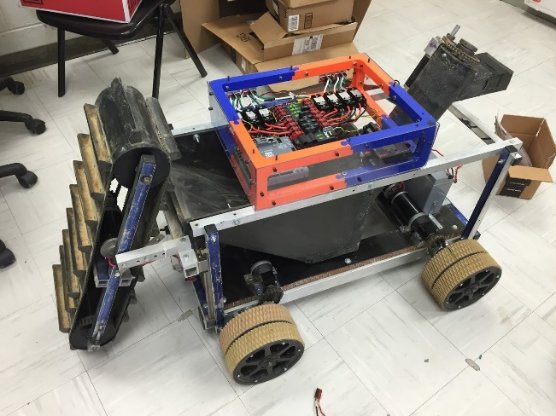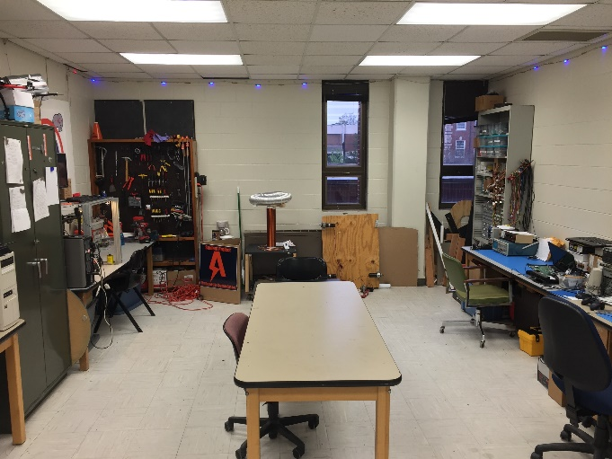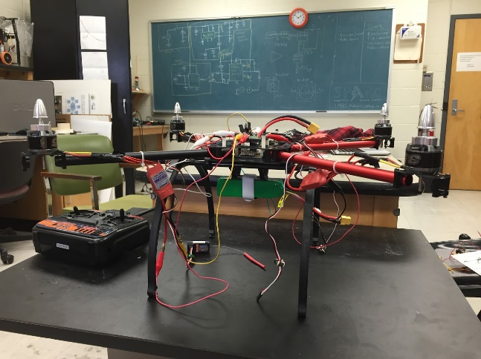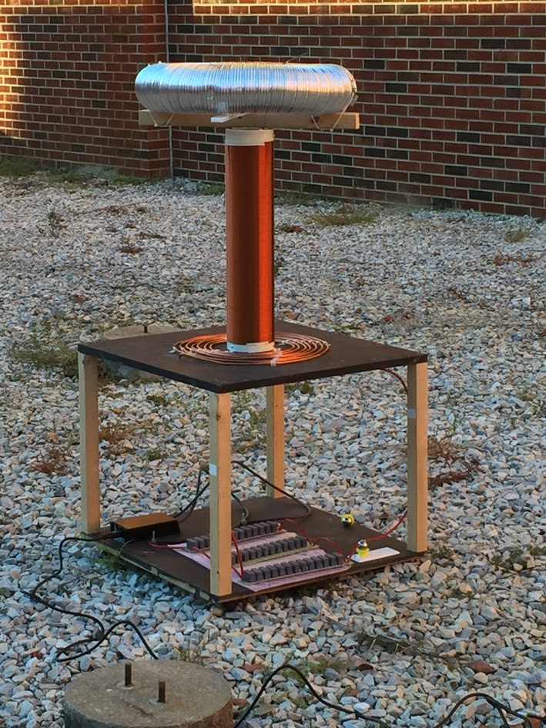\

**Who can join?**

**→** Any student regardless of major or year can join.

**→** No experience is required and there is no required commitment

**What is SPARC?**

**→** SPARC stands for Student Project and Research Committee.

**→** It basically functions as Auburn’s own “makerspace.”

**→** SPARC provides the tools, resources, and the funds for projects.

**Do you want to?**

**→** Get hands on experience and apply the concepts you learn in your classes.

**→** Learn programming, soldering, fabricating, 3D design, how to operate a 3D printer, and much more.

**→** Build robots, quadcopters, Tesla Coils, or any other project you can come up with.

https://twitter.com/SPaRC_Auburn

https://github.com/SPARC-Auburn

<http://sparc-auburn.github.io/>

sparc.auburn@gmail.com

**Lab Location:**

Broun 368

**Fall 2016 Meeting Time:**

Tuesdays 6-7 in Broun 235